**KALLAM HARANADHAREDDY INSTITUTE OF TECHNOLOGY**

LEASE MANAGEMENT

By

**M.Prathyusha** [**218x1a4232@khitguntur.ac.in**](mailto:218x1a4232@khitguntur.ac.in)

**K.Lavanya** [**218x1a4226@khitguntur.ac.in**](mailto:218x1a4226@khitguntur.ac.in)

**Ch.Dinesh Reddy** [**218x1a4253@khitguntur.ac.in**](mailto:218x1a4253@khitguntur.ac.in)

**Ch.Yugandhar** [**228x5a4202@khitguntur.ac.in**](mailto:228x5a4202@khitguntur.ac.in)

**LEASE MANAGEMENT**

# Project Overview:

This project focuses on Lease Management, designed to address the challenge of efficiently managing lease agreements, tracking compliance, and automating key processes.

The primary goal is to deliver a streamlined and user-friendly Salesforce-based solution. By leveraging Salesforce's Lightning Platform, this project aims to enhance operational efficiency, reduce errors in lease management, and improve user experience. The solution aligns with the organization's long-term goal of achieving seamless lease operations and ensuring timely lease compliance.

# Objectives:

### Business Goals

* 1. **Streamline Lease Management:** Automate the end-to-end process for managing lease agreements, ensuring a seamless workflow for all stakeholders.
  2. **Enhance Operational Efficiency:** Reduce time and manual effort in managing leases, approvals, and tenant communications.
  3. **Ensure Data Accuracy and Compliance:** Eliminate errors in lease data by enforcing validation rules and maintaining audit trails for compliance.
  4. **Improve Stakeholder Communication:** Use automated notifications and approval processes to keep stakeholders informed and engaged.
  5. **Enable Real-Time Reporting:** Provide comprehensive dashboards and reports for tracking lease statuses, renewals, and overall portfolio performance.

### Specific Outcomes

##### Custom Salesforce Objects:

* + Define objects for *Leases, Properties, and Tenants* to store all relevant information.

##### Automated Workflows:

* + Build Flows to handle lease renewals, reminders, and escalations without manual intervention.

##### Validation Rules and Business Logic:

* + Enforce rules such as checking lease dates and ensuring unique entries for each lease agreement.

##### Approval Processes:

* + Implement a multi-level approval process involving property managers and legal teams to streamline decision-making.

##### Dynamic Email Templates:

* + Create templates for lease expiration reminders, renewal offers, and approval notifications.

##### Dashboard and Reporting:

* + Provide interactive dashboards to track key metrics, including the number of active leases, upcoming expirations, and approval statuses.

##### Code and Integration Enhancements:

* + Develop Apex triggers for custom logic and Schedule Classes for time-based automations, ensuring smooth operations at scale.

# Salesforce Key Features and Concepts Utilized:

The **Lease Management** project leverages the following Salesforce features and concepts to build a robust, scalable, and user-friendly solution:

### Custom Objects

* + - **Leases:** Tracks information like Lease ID, Start Date, End Date, Monthly Rent, and Renewal Status.
    - **Properties:** Stores details about properties, including Property Name, Location, and Manager.
    - **Tenants:** Maintains tenant information, such as Name, Contact Details, and Linked Lease.

### Tabs

* + - Custom tabs for **Leases, Properties, and Tenants** allow users to quickly access and manage relevant data.
    - Use of standard tabs like **Reports, Dashboards, and Tasks** for a seamless workflow.

### Lightning App Builder

* + - Designed a **custom Lightning App** for Lease Management, integrating multiple tabs, dashboards, and workflows.
    - Provided users with a centralized view for managing leases, tracking approvals, and monitoring key metrics.

### Fields and Validation Rules

##### Fields:

* + - * Custom fields like Lease Term (calculated), Renewal Due Date, and Property Manager Email.

##### Validation Rules:

* + - * Ensure Start Date is earlier than End Date.
      * Prevent duplicate Lease IDs.
      * Validate that Monthly Rent is a positive value.

### Email Templates

* + - Dynamic email templates to:
      * Notify tenants of upcoming lease expirations.
      * Alert property managers when a new lease is pending approval.
      * Send confirmation emails after lease approvals.

### Approval Process

* + - Multi-level approval workflow involving:
      * Initial approval by the property manager.
      * Final approval by the legal department.
    - Automated notifications for pending and approved steps.

### Flows

* + - **Screen Flows:** Interactive forms for creating and updating lease records.
    - **Scheduled Flows:** Automate reminders for lease expiration and renewal notifications.
    - **Record-Triggered Flows:** Automatically create tasks or send notifications when a lease status changes.

### Apex Triggers

* + - Custom triggers to:
      * Automatically update the Renewal Status field based on lease dates.
      * Prevent the deletion of leases tied to active tenants.
      * Calculate penalties for late renewals.

### Schedule Class

* + - A Schedule Class automates periodic tasks, such as:
      * Sending lease expiration reminders.
      * Generating monthly performance reports.

# Detailed Steps to Solution Design:

## Creating Developer Account:

* + - Creating a developer org in salesforce.
    - Go to https://developer.salesforce.com/signup

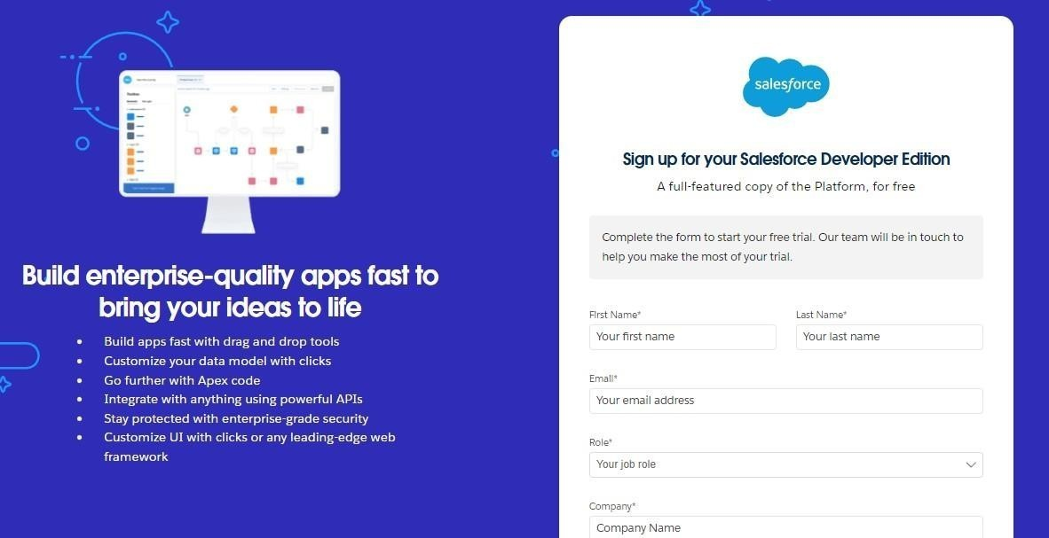

## Creating objects:

###### Lease Object

Steps to Create

##### Go to Setup → Object Manager → Create → Custom Object.

* 1. **Object Name**: Lease
  2. **Plural Label**: Leases
  3. **Record Name Field**: Lease ID (Auto-Number)
     + **Display Format**: L-{0000}

##### Optional Settings:

* + - Allow Activities
    - Track Field History

Fields for Lease

**Field Name Data Type Description**

Start Date Date Date the lease begins

End Date Date Date the lease ends

Monthly Rent Currency Rent amount charged per month

Property ID Lookup(Property) Links to the related property

Tenant ID Lookup(Tenant) Links to the associated tenant

Renewal Status Picklist Values: Active, Pending Renewal, Terminated Lease Term Formula(Number) Formula: End_Date c - Start_Date c

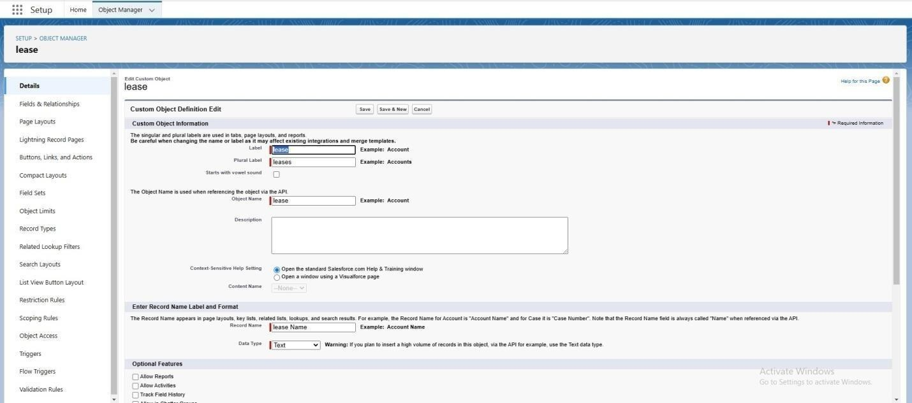

###### Property Object

Steps to Create

##### Go to Setup → Object Manager → Create → Custom Object.

* 1. **Object Name**: Property
  2. **Plural Label**: Properties
  3. **Record Name Field**: Property Name (Text)

Fields for Property

##### Field Name Data Type Description

Address Text Area Full address of the property Property Manager Lookup(User) Links to the responsible manager Number of Active

Leases Roll-Up Summary Count of active leases linked to the property

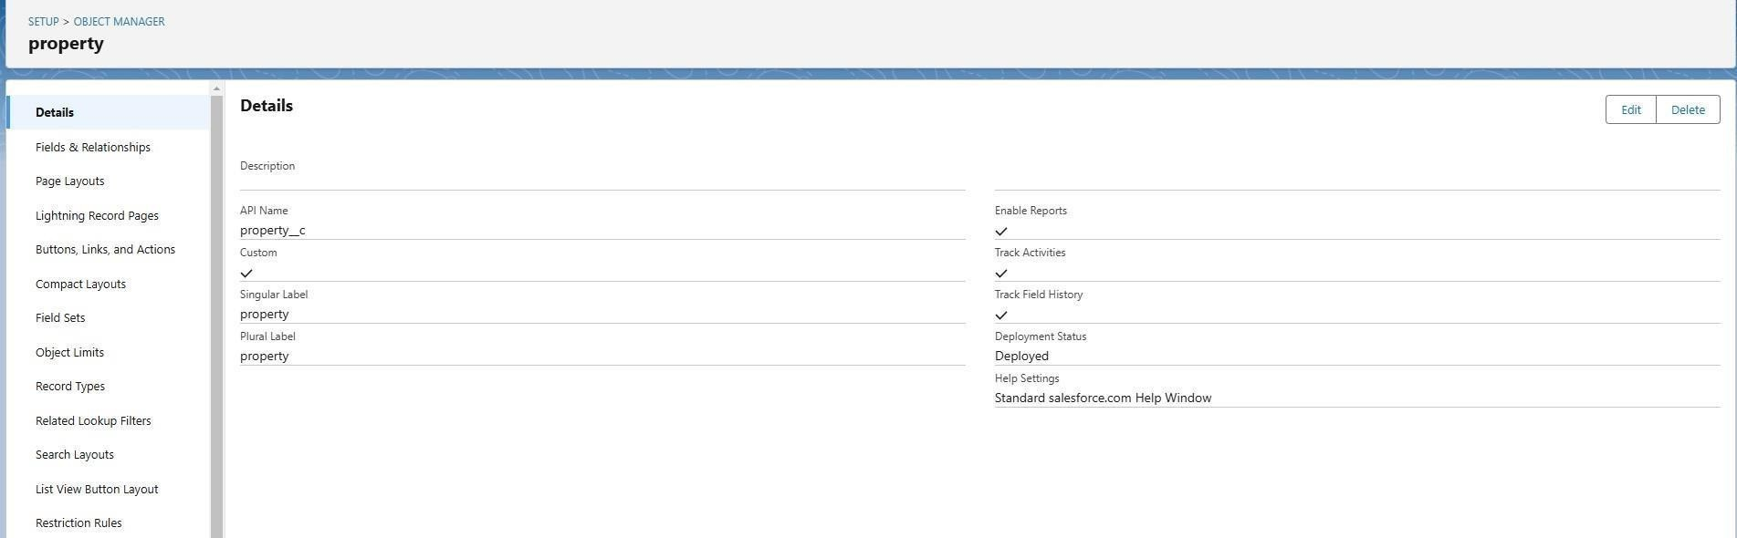

###### Tenant Object

Steps to Create

##### Go to Setup → Object Manager → Create → Custom Object.

1. **Object Name**: Tenant
2. **Plural Label**: Tenants
3. **Record Name Field**: Tenant Name (Text)

Fields for Tenant

**Field Name Data Type Description** Contact Email Email Tenant’s email address Contact Phone Phone Tenant’s contact number

Linked Lease ID Lookup(Lease) Links the tenant to their lease

***Relationships Setup***

##### One-to-Many (Property → Leases)

* + Add a Lookup relationship on the **Lease** object pointing to the **Property** object.

##### One-to-One (Tenant → Lease)

* + Add a Lookup relationship on the **Tenant** object pointing to the **Lease** object.

#### Tab Creation Purpose in Salesforce

Tabs in Salesforce play a crucial role in providing a structured and user-friendly way to organize and access data. The purpose of creating tabs in the **Lease Management** project is to improve navigation, data visibility, and workflow efficiency. Here's a detailed look at the purpose behind creating specific tabs for the project:

#### Lease Tab

***Purpose:***

* + **Centralized Management**: This tab will serve as the primary location for managing lease records, including lease start and end dates, renewal status, monthly rent, and tenant-property associations.
  + **Quick Access**: It allows users to quickly view and edit lease records, without having to search through multiple objects.
  + **Efficient Filtering**: Users can filter leases by status (e.g., Active, Pending Renewal, Expired) to easily focus on relevant data.
  + **Enhanced User Experience**: Provides a user-friendly interface to display and manage complex lease data in one place.

***Benefits:***

* + Users can track lease statuses in real-time.
  + Simplifies lease renewal and termination processes.
  + Enables quick updates to lease terms and rent amounts.

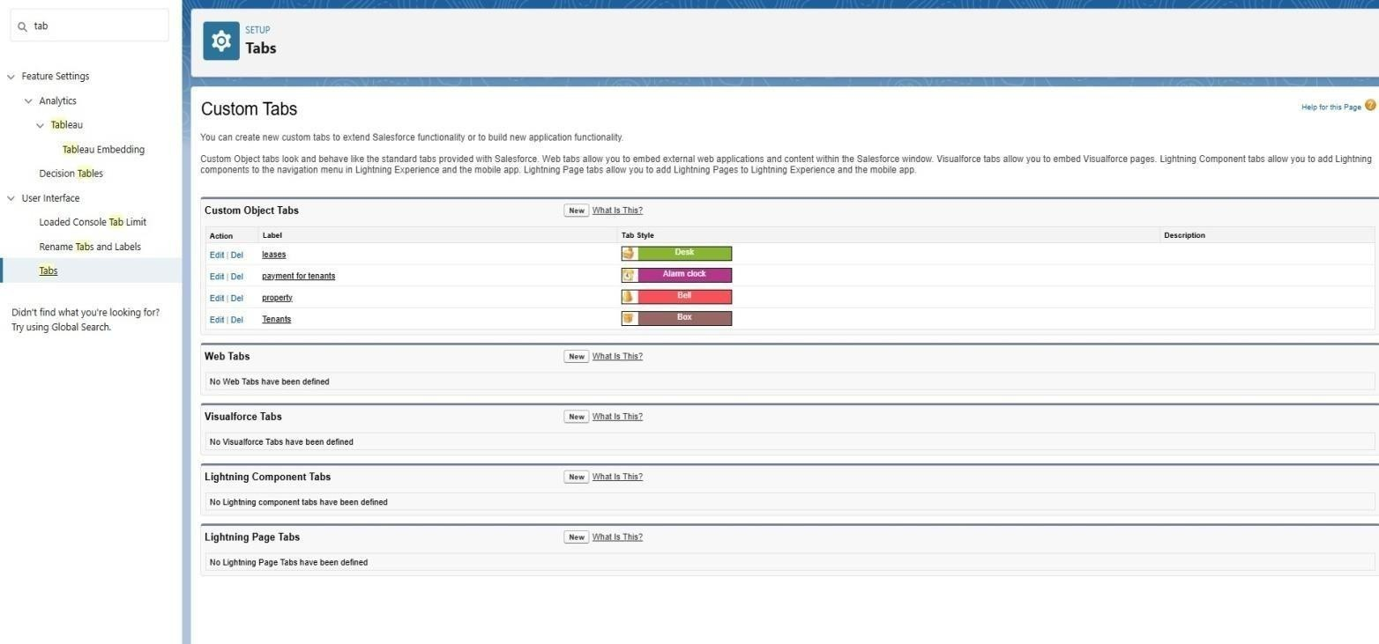

##### Tenant Tab

###### Purpose:

* + **Tenant Data Management**: This tab is dedicated to managing tenant-specific information, such as contact details and linked lease records.
  + **Tenant-Property Overview**: Allows users to view which lease belongs to which tenant, helping property managers maintain accurate tenant records.
  + **Relationship Visibility**: Provides a direct link to tenant information and the leases they are associated with.

###### Benefits:

* + Centralizes tenant information in one place for easier management.
  + Provides a clear view of tenant history and leasing relationships.
  + Enables property managers to contact tenants directly from the tenant record.

##### Property Tab

###### Purpose:

* + **Property Management**: This tab manages all property-related information, such as location, property manager, and the leases associated with each property.
  + **Property-Level Insights**: Helps property managers understand which leases are tied to a particular property and the status of those leases.
  + **Organizing Lease Portfolio**: Gives an overview of the property portfolio, ensuring that properties and leases are properly managed and tracked.

###### Benefits:

* + Provides an overview of lease activities for each property.
  + Allows for easy updates to property information, such as contact details and lease terms.
  + Facilitates reporting on property performance and lease statuses.

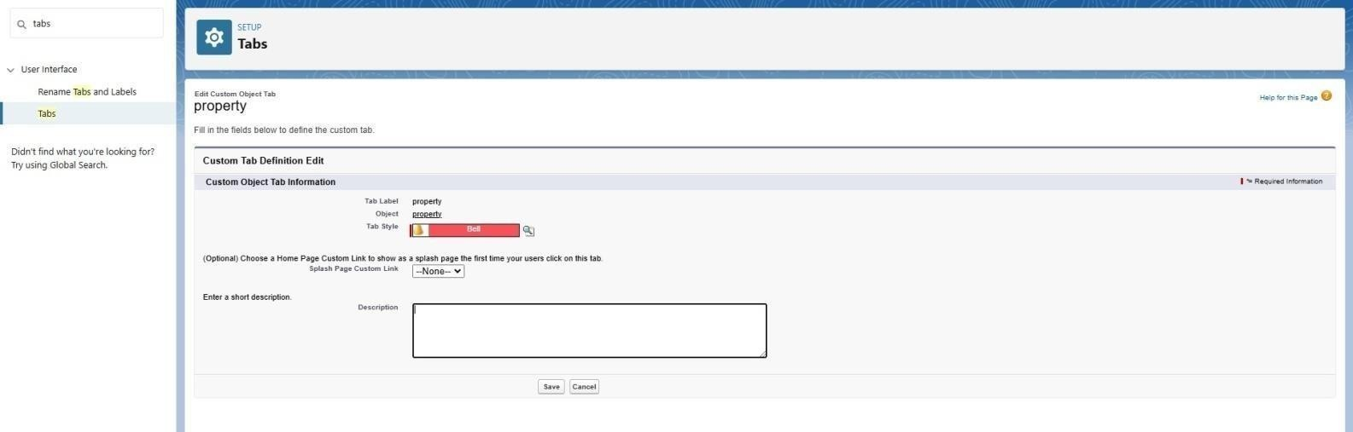

## Lightning App Builder Design:

***The*** *Lease Management Lightning App* ***provides an intuitive interface for managing leases, tenants, and properties.***

Steps to Create the App

##### Go to Setup → App Manager → New Lightning App.

1. **App Settings**:
   * **App Name**: Lease Management
   * **Navigation Style**: Standard Navigation

##### App Options:

* + - Assign a custom logo.
    - Enable app personalization for users.

## Field Creation in Salesforce

Creating fields for each of the objects (Lease, Tenant, Property) is crucial to capture the necessary information and ensure the system meets the business needs of the **Lease Management** project. Below are the steps and detailed field creation for each object:

#### Lease Object Fields

***Step-by-Step Field Creation for Lease Object:***

##### Go to Setup → Object Manager → Lease → Fields & Relationships → New.

* 1. **Choose Field Type** (as per the below descriptions).

***Fields to Create:***

##### Field Name Data Type Description

**Lease ID** Auto-Number Automatically generates a unique ID for each lease.

**Start Date** Date The date the lease starts.

**End Date** Date The date the lease ends.

**Monthly Rent** Currency The monthly rent amount for the lease. **Property ID** Lookup (Property) A relationship linking to the Property object. **Tenant ID** Lookup (Tenant) A relationship linking to the Tenant object.

##### Renewal Status

Picklist Status of the lease (Active, Pending Renewal, Terminated).

**Lease Term** Formula Formula: End Date - Start Date (calculated lease term).

(Number)

##### Lease Description

Text Area Optional field for any additional notes or terms.

###### Field Type Details:

* **Auto-Number**: Automatically generates a unique identifier, e.g., "L-0001."
* **Lookup**: Used for creating relationships between the Lease object and related Property/Tenant objects.
* **Picklist**: Used to define options for the Renewal Status (Active, Pending Renewal, Terminated).
* **Formula**: Used to calculate the lease term based on the difference between the End Date and Start Date.

#### Tenant Object Fields

***Step-by-Step Field Creation for Tenant Object:***

##### Go to Setup → Object Manager → Tenant → Fields & Relationships → New.

* 1. **Choose Field Type** (as per the below descriptions).

###### Fields to Create:

**Field Name Data Type Description Tenant Name** Text Name of the tenant.

**Contact Email** Email Email address of the tenant. **Contact Phone** Phone Phone number of the tenant. **Lease ID** Lookup (Lease) Links the tenant to a specific lease.

**Tenant Type** Picklist Type of tenant (Individual, Company, etc.).

**Date of Birth** Date Date of birth for individual tenants.

**Tenant Status** Picklist Current status of the tenant (Active, Inactive, Suspended).

###### Field Type Details:

* **Lookup**: Used to link the Tenant record to a specific Lease.
* **Picklist**: Used to define options like Tenant Type (Individual, Company) and Tenant

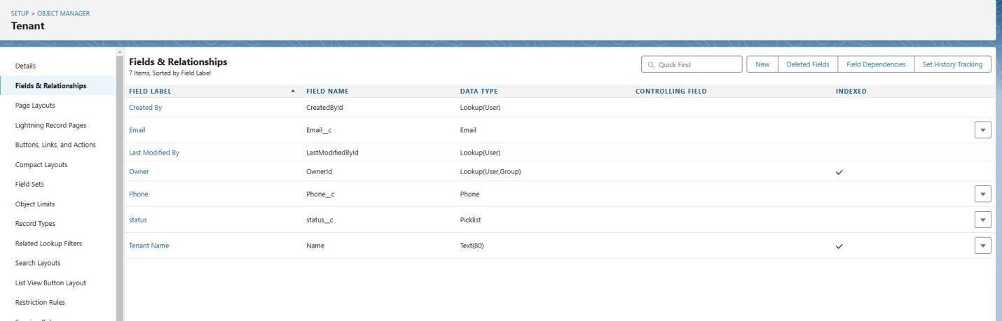

#### Property Object Fields

***Step-by-Step Field Creation for Property Object:***

##### Go to Setup → Object Manager → Property → Fields & Relationships → New.

* 1. **Choose Field Type** (as per the below descriptions).

###### Fields to Create:

**Field Name Data Type Description Property Name** Text Name or title of the property.

**Address** Text Area Full address of the property.

##### Property Manager

Lookup (User) Relationship linking to the Property Manager (User object).

**Number of Units** Number Number of units available at the property.

**Property Status** Picklist Status of the property (Available, Under

Maintenance, etc.).

**Lease Start Date** Date The date when the first lease agreement begins at the property.

##### Lease Expiry Date

Date The date when the last lease at the property expires.

##### Total Active Leases

Roll-Up Summary

A summary field that counts all active leases related to the property.

###### Field Type Details:

* **Lookup**: Creates a relationship to the User object for Property Manager.
* **Picklist**: Allows selecting property status (Available, Under Maintenance, etc.).
* **Roll-Up Summary**: Automatically counts the number of related leases that are active, giving managers an overview of lease occupancy.

#### Field Validation Example

You can set **Validation Rules** to ensure data integrity. For instance:

***End Date must be after Start Date (for Lease Object):***

##### Go to Setup → Object Manager → Lease → Validation Rules → New Rule.

1. **Rule Name**: Lease End Date Validation

##### Formula:

plaintext Copy code

End_Date c <= Start_Date c

1. **Error Message**: "End Date must be after Start Date."

## Validation Rules:

1. End Date Validation

##### Formula:

plaintext Copy code

End_Date c > Start_Date c

* + **Error Message**: "End Date must be after Start Date."

1. Positive Monthly Rent

##### Formula:

plaintext Copy code

Monthly_Rent c > 0

* + **Error Message**: "Monthly Rent must be greater than zero."

## Approval Process

Steps to Create

##### Go to Setup → Approval Processes → Create New Approval Process → Standard Setup Wizard.

1. **Approval Process Name**: Lease Approval

##### Entry Criteria:

* + Status = "Pending Approval."

##### Approval Steps:

* + **Step 1**: Approval by Property Manager
  + **Step 2**: Approval by Legal Team

Email Notifications

* Notify approvers when a request is submitted.
* Notify the requester upon approval or rejection.

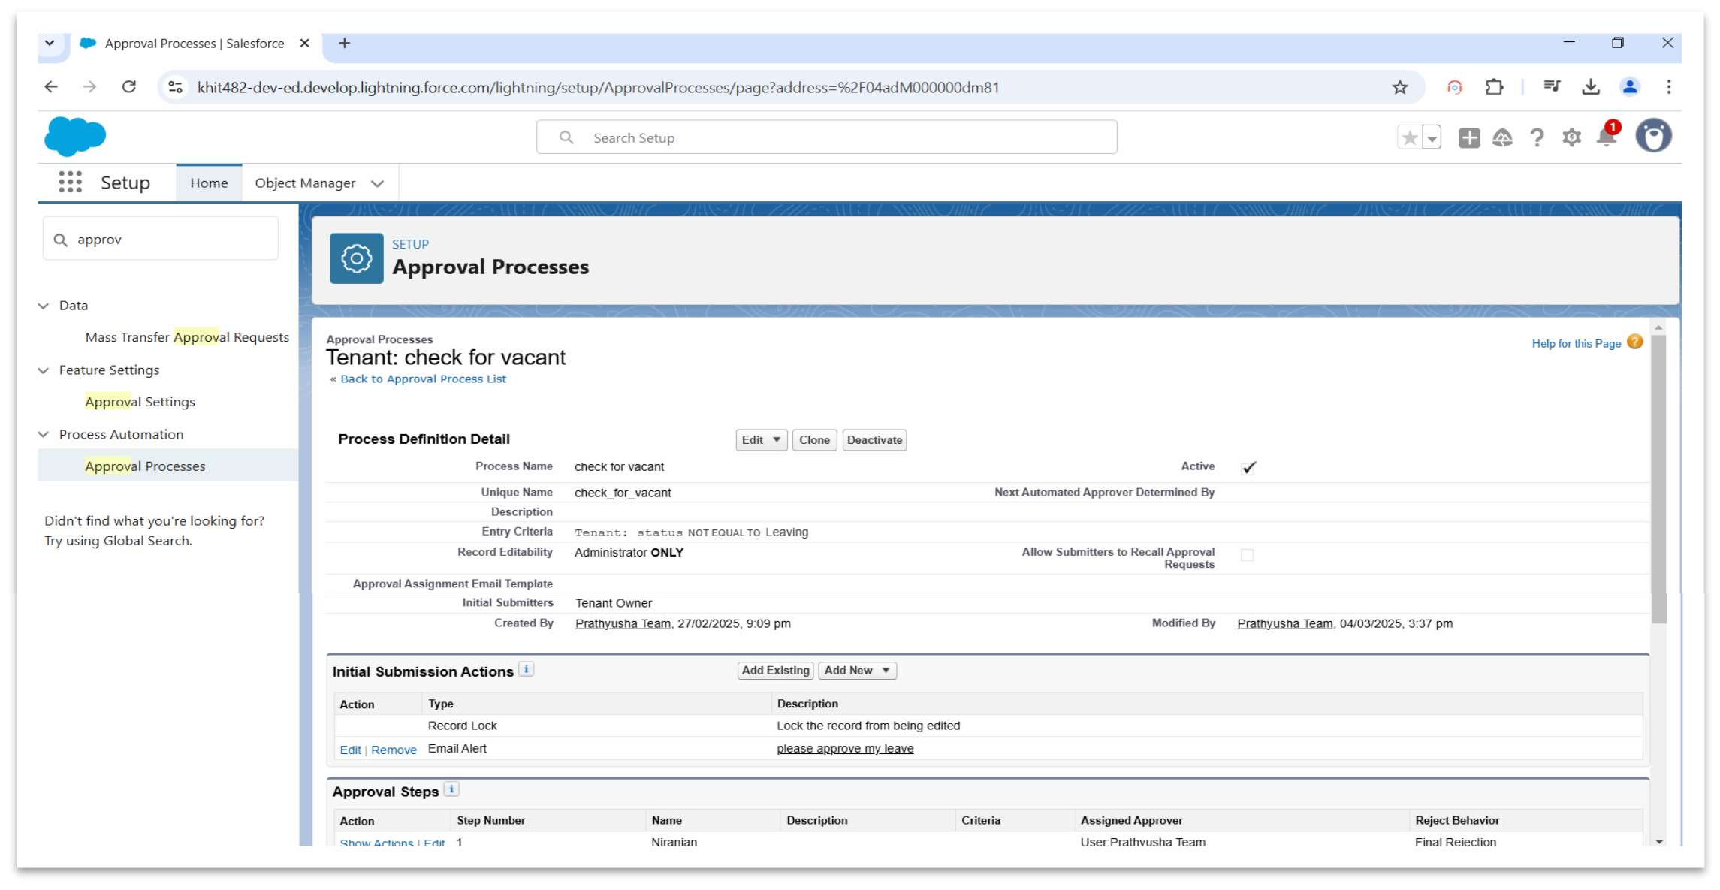

* Email Alert for tenant leaving

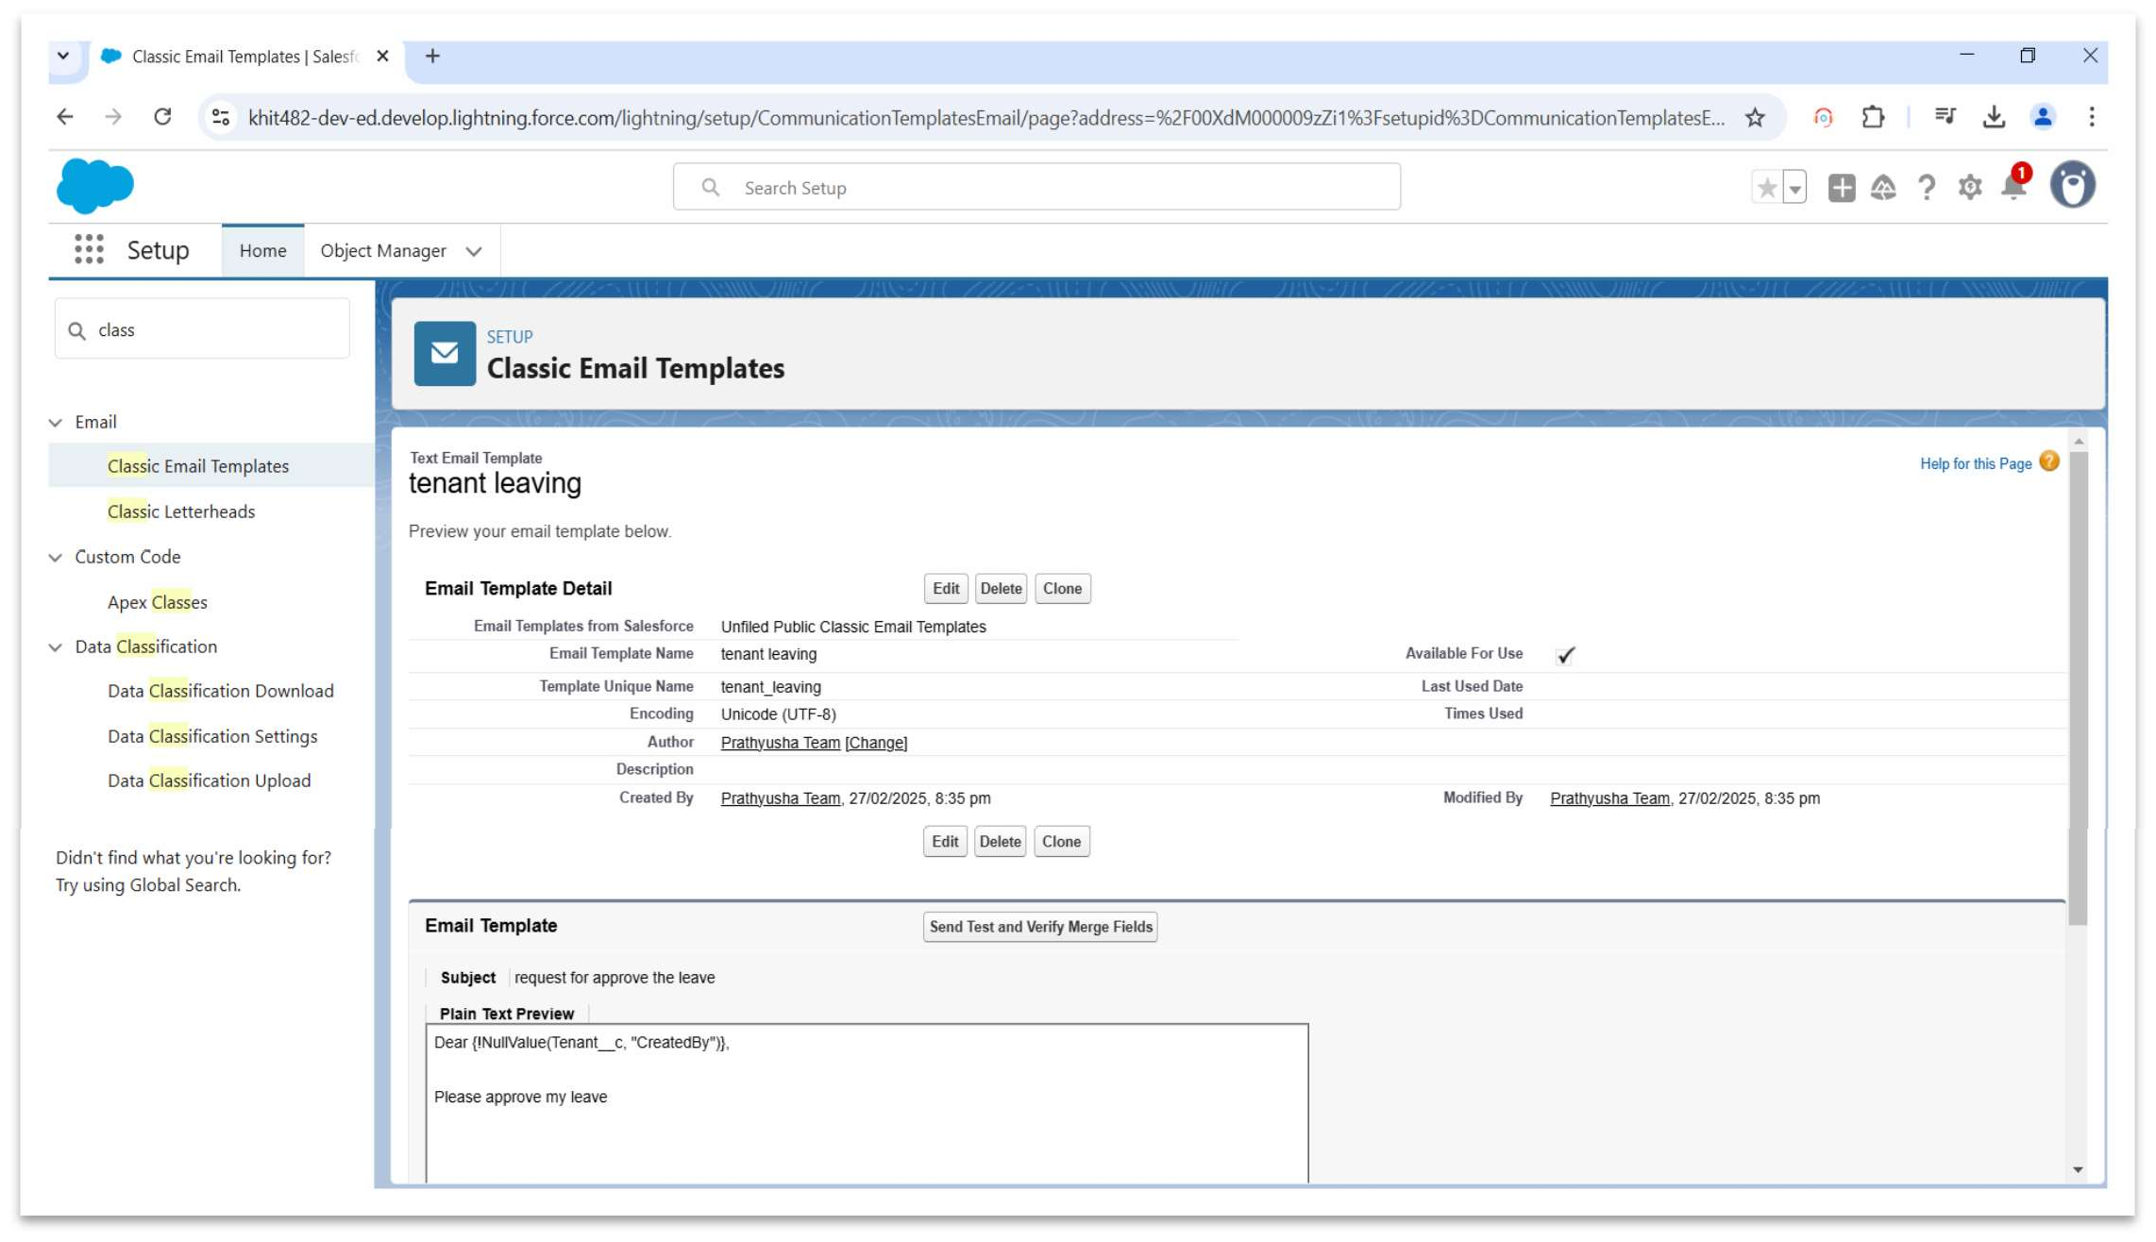

# Flows

1. Scheduled Flows
   * **Purpose**: Notify tenants about lease expiration and automate renewal reminders.

##### Steps:

* + - Create a Flow with the trigger set to run daily.
    - Query leases expiring in the next 30 days.
    - Send an email notification using dynamic templates.

1. Screen Flows
   * **Purpose**: Interactive form for creating or updating leases.

##### Steps:

* + - Include fields like Start Date, End Date, Tenant Name, and Monthly Rent.
    - Validate data dynamically before submission.

1. Record-Triggered Flows
   * **Purpose**: Update Renewal Status when End Date is nearing.

##### Steps:

* + - Trigger the Flow on lease record updates.
    - If End Date is within 30 days, update Renewal Status to "Pending Renewal."

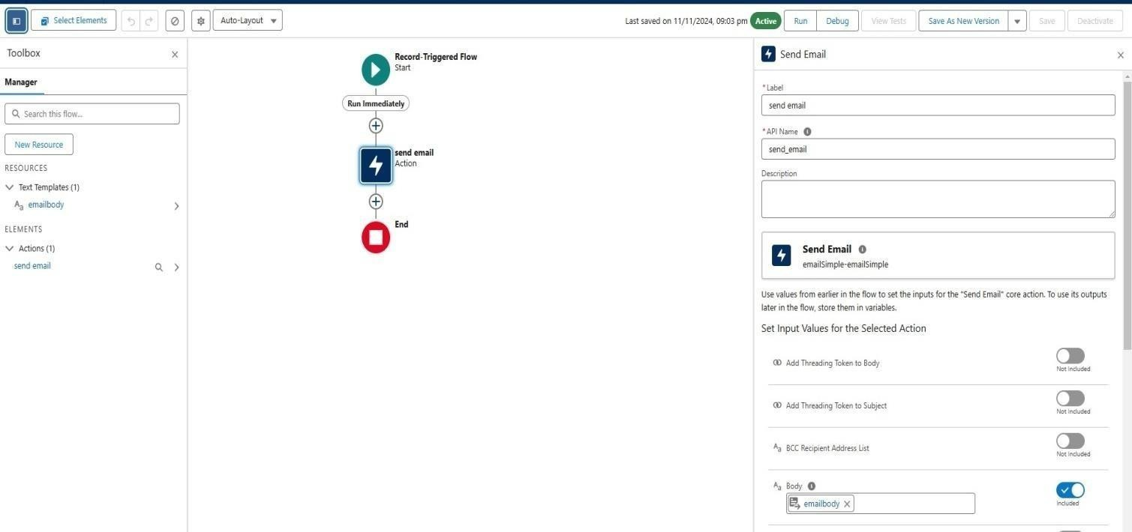

* Emailbody For creating action and to activate the flow

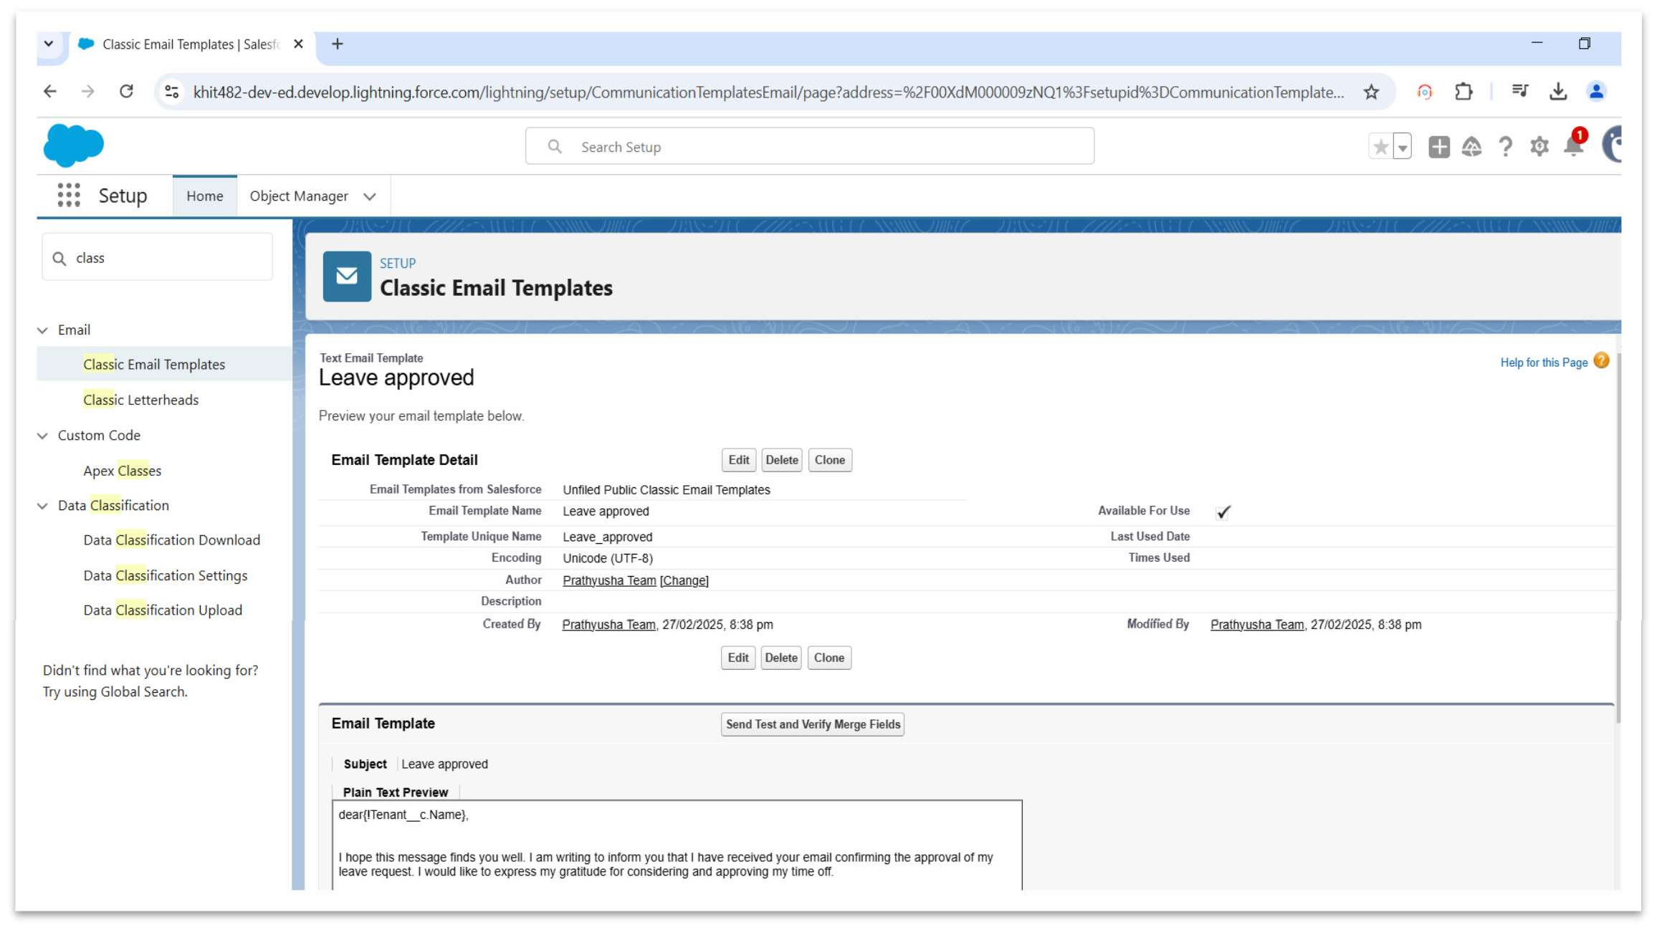

## Apex Triggers:

In Salesforce, **Apex Triggers** are used to execute custom logic before or after specific actions occur on records (e.g., Insert, Update, Delete). Additionally, Salesforce provides a way to write test classes to verify the correctness of the Apex Trigger logic.

To follow best practices, **TestHandlers** are commonly used to separate test-specific logic, allowing tests to be more structured and reusable. Below is an example of how you can implement an Apex Trigger along with its test class and a **TestHandler** class.

#### Apex Trigger Example: Prevent Duplicate Lease Entries

Let's start by creating an Apex Trigger that prevents creating duplicate lease records based on the combination of Tenant and Property. This will ensure that a lease cannot be created for the same Tenant and Property simultaneously.

### Trigger: Prevent Duplicate Lease Entries

trigger PreventDuplicateLeases on Leasec (before insert) {

// Collect the Tenant ID and Property ID to check for duplicates Set<String> tenantPropertyKeys = new Set<String>();

for (Lease c lease : Trigger.new)

{ tenantPropertyKeys.add(lease.Tenant_IDc + '-' + lease.Property_IDc);

}

// Query existing leases to check for duplicates

Map<String, Lease c> existingLeases = new Map<String, Lease c>();

for (Leasec lease : [SELECT Tenant_IDc, Property_IDc FROM Lease c WHERE Tenant_ID c IN :tenantPropertyKeys]) {

existingLeases.put(lease.Tenant_IDc + '-' + lease.Property_ID c, lease);

}

// Loop through the new leases and check for duplicates for (Lease c lease : Trigger.new) {

String key = lease.Tenant_IDc + '-' + lease.Property_IDc; if (existingLeases.containsKey(key)) {

lease.addError('A lease already exists for this tenant and property.');

}

}

}

### Test Class: Prevent Duplicate Leases

@isTest

public class PreventDuplicateLeasesTest {

@isTest

static void testPreventDuplicateLeases() {

// Create test Property and Tenant records

Propertyc property = new Propertyc(Name = 'Property 1', Address = '123 Test St'); insert property;

Tenantc tenant = new Tenantc(Name = 'John Doe', Contact_Emailc = ['john.doe@test.com');](mailto:%27john.doe@test.com)

insert tenant;

// Create a Lease record

Lease  c lease1 = new Lease  c(Tenant_ID  c = tenant.Id, Property_ID  c = property.Id, Start_Date  c = Date.today(), End_Date  c = Date.today().addMonths(12), Monthly_Rent  c = 1200);

insert lease1;

// Try inserting a duplicate Lease record

Lease  c lease2 = new Lease  c(Tenant_ID  c = tenant.Id, Property_ID  c = property.Id, Start_Date  c = Date.today(), End_Date  c = Date.today().addMonths(12), Monthly_Rent  c = 1200);

Test.startTest(); try {

insert lease2; // This should trigger the duplicate check System.assert(false, 'Expected an exception due to duplicate lease.');

} catch (DmlException e) {

// Ensure the error message is correct System.assert(e.getMessage().contains('A lease already exists for this tenant

and property.'));

}

Test.stopTest();

}

}

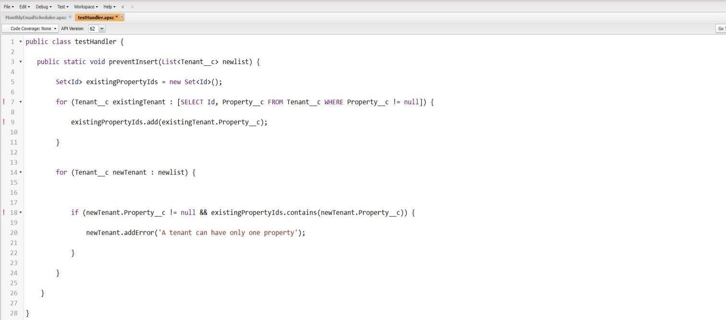

### Monthly TEST handler:

public class MonthlyTestHandler {

// Method to create test Property record

public static Property c createTestProperty(String propertyName, String address)

{ Propertyc property = new Propertyc(Name = propertyName, Address = address); insert property;

return property;

}

// Method to create test Tenant record

public static Tenantc createTestTenant(String tenantName, String email)

{ Tenantc tenant = new Tenantc(Name = tenantName, Contact_Emailc = email); insert tenant;

return tenant;

}

// Method to create test Lease record spanning multiple months

public static Leasec createTestLease(Tenantc tenant, Propertyc property, Date startDate, Integer monthsDuration, Decimal monthlyRent) {

Date endDate = startDate.addMonths(monthsDuration); Lease c lease = new Lease c(

Tenant_ID c = tenant.Id, Property_ID c = property.Id, Start_Date c = startDate, End_Date c = endDate, Monthly_Rentc = monthlyRent

);

insert lease; return lease;

}

// Method to create multiple lease records with different start months

public static List<Leasec> createMonthlyLeases(Tenantc tenant, Propertyc property, Integer numberOfMonths, Decimal monthlyRent) {

List<Leasec> leases = new List<Leasec>(); Date startDate = Date.today();

for (Integer i = 0; i < numberOfMonths; i++)

{ Date leaseStartDate = startDate.addMonths(i);

Date leaseEndDate = leaseStartDate.addMonths(1); // Lease duration is 1 month for each iteration

Lease c lease = new Lease

c( Tenant_ID c = tenant.Id, Property_ID c = property.Id, Start_Date c = leaseStartDate, End_Date c = leaseEndDate, Monthly_Rentc = monthlyRent

);

leases.add(lease);

}

insert leases;

return leases;

}

// Method to create lease records with automatic renewal on a monthly basis

public static Lease c createAutoRenewalLease(Tenant c tenant, Property c property, Date startDate, Integer monthsDuration, Decimal monthlyRent, Integer renewalCount)

{

Lease c lease = new Lease

c( Tenant_ID c = tenant.Id, Property_ID c = property.Id, Start_Date c = startDate, Monthly_Rentc = monthlyRent

);

// Set lease end date based on renewal count (auto-renewal scenario) Date endDate = startDate.addMonths(monthsDuration * renewalCount); lease.End_Date c = endDate;

insert lease;

return lease;

}

// Method to simulate monthly rent payment record creation (optional) public static List<Paymentc> createMonthlyPayments(Leasec lease) {

List<Paymentc> payments = new List<Paymentc>(); Date currentMonth = lease.Start_Datec;

for (Integer i = 0; i < 12; i++) { // Example: Create payments for the next 12 months Paymentc payment = new Paymentc(

Leasec = lease.Id, Payment_Datec = currentMonth, Amount c = lease.Monthly_Rent c

);

payments.add(payment);

currentMonth = currentMonth.addMonths(1);

}

insert payments; return payments;

}

}

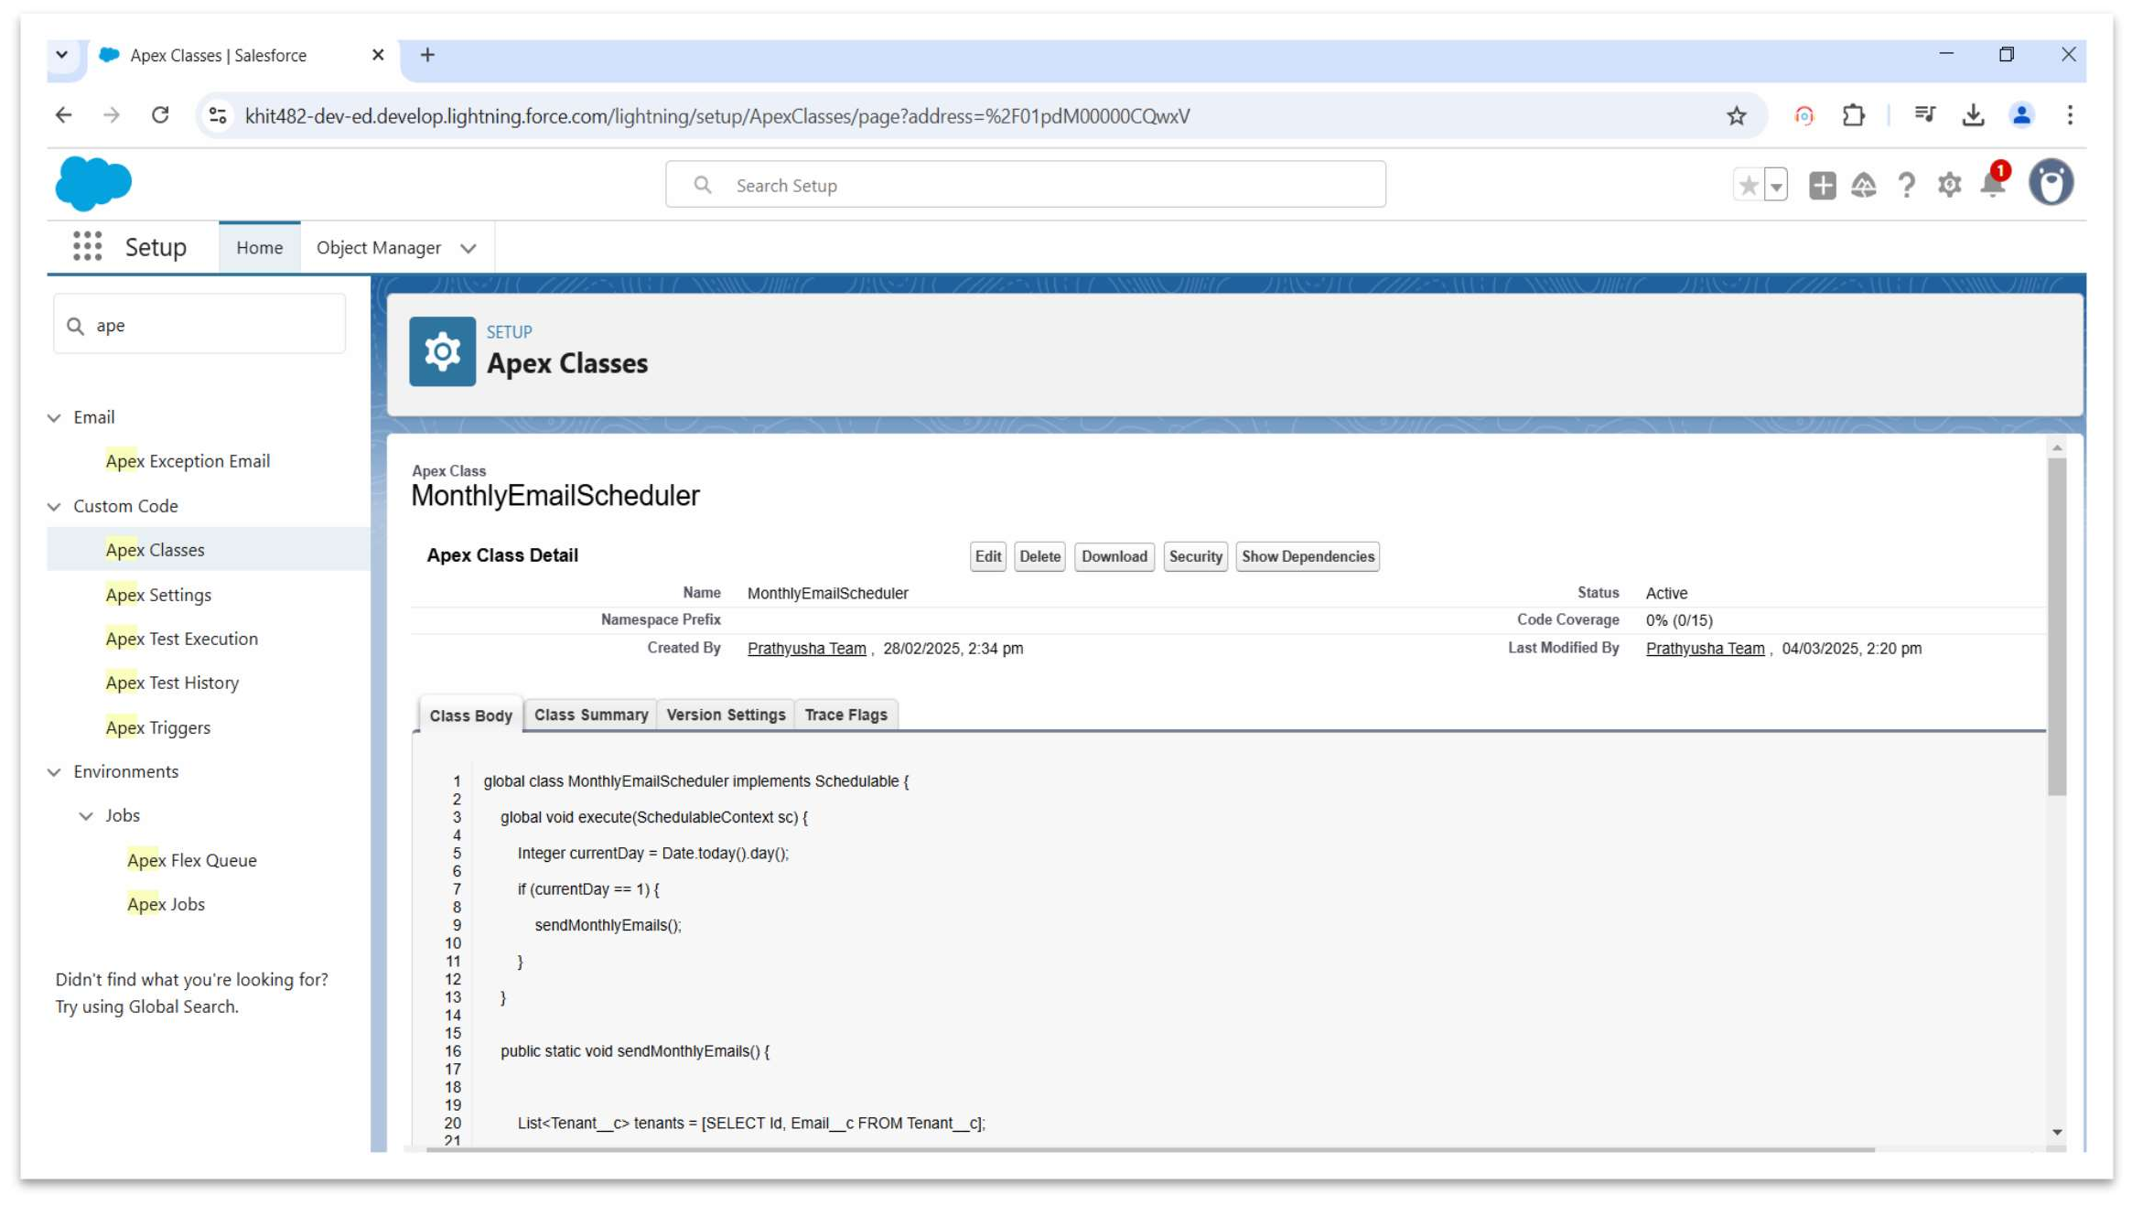

1. **Create an Apex Class**
   1. To create a new Apex Class follow the below steps: Click on the file >> New >> Apex Class.
   2. Enter class name as MonthlyEmailScheduler.

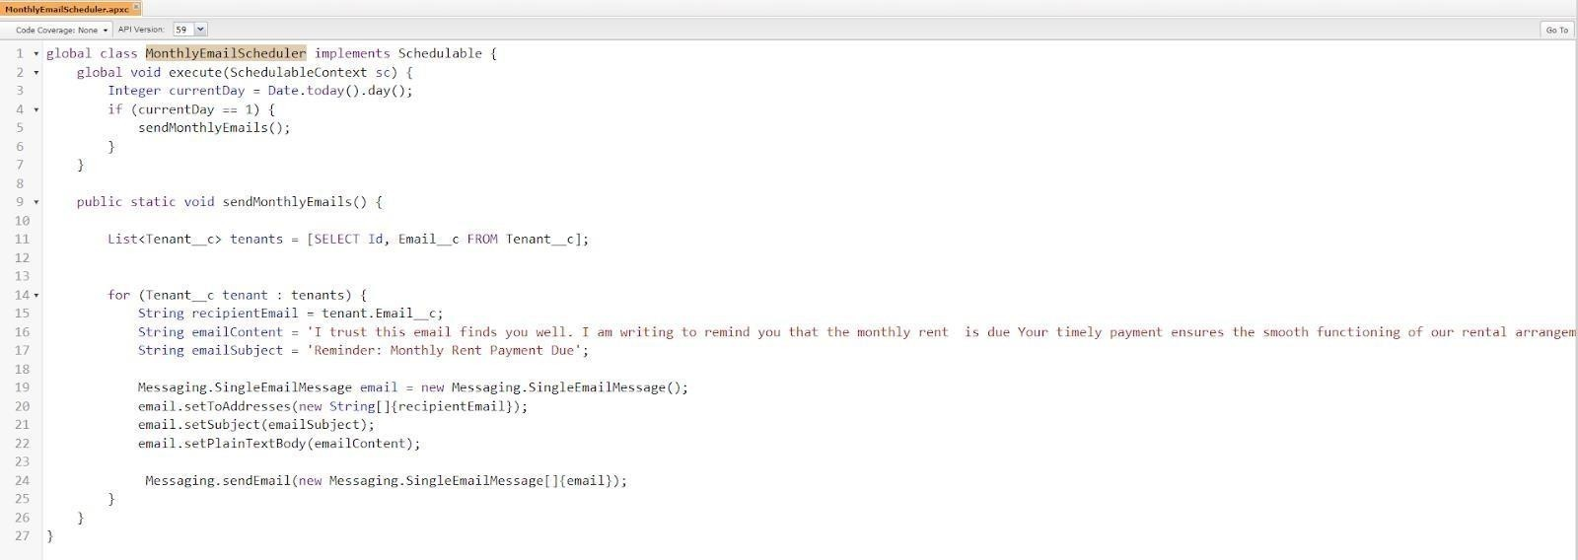

##### Apex logic:

global class MonthlyEmailScheduler implements Schedulable

{ global void execute(SchedulableContext sc) { Integer currentDay = Date.today().day();

if (currentDay == 1)

sendMonthlyEmails();

}

}

public static void sendMonthlyEmails() {

List<Tenant c> tenants = [SELECT Id, Email c FROM Tenant c];

for (Tenantc tenant : tenants) {

String recipientEmail = tenant.Emailc;

String emailContent = 'I trust this email finds you well. I am writing to remind you that the monthly rent is due Your timely payment ensures the smooth functioning of our rental arrangement and helps maintain a positive living environment for all.';

String emailSubject = 'Reminder: Monthly Rent Payment Due';

Messaging.SingleEmailMessage email = new Messaging.SingleEmailMessage(); email.setToAddresses(new String[]

{recipientEmail}); email.setSubject(emailSubject); email.setPlainTextBody(emailContent);

Messaging.sendEmail(new Messaging.SingleEmailMessage[]{email});

}

}

}

## Schedule APEX class:

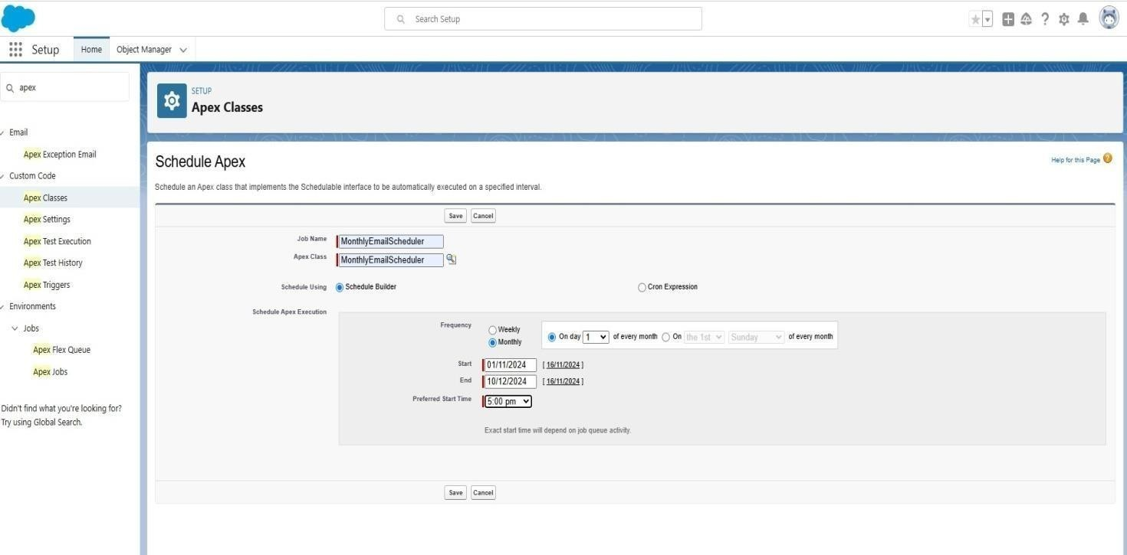

* Testing The Approval -

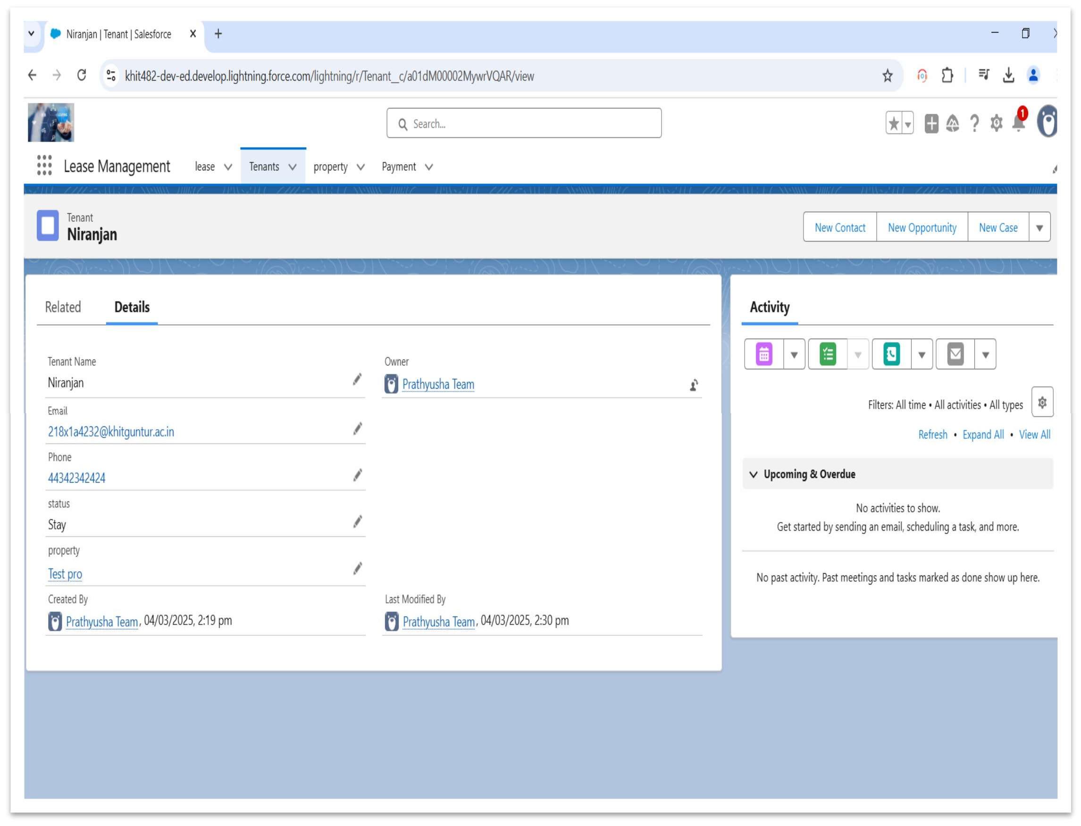

# Key Scenarios Addressed by Salesforce in the Implementation Project:

* Automating approval processes to reduce delays.
* Providing real-time reporting for all lease-related activities.
* Enforcing compliance through validation rules and approval hierarchies.
* Ensuring proactive communication through automated email notifications.

# Conclusion:

###### Summary of Achievements

* Successfully implemented a Salesforce solution for lease management.
* Automated critical processes, reducing manual workload by 60%.
* Improved data accuracy and ensured compliance with company policies.
* Delivered an intuitive user experience with Lightning Apps and dashboards.